**EXPERIMENT NO. 2**

**TO COMPARE VARIOUS NETWORK HARDWARE DEVICES USING CISCO**  **PACKET TRACER**

**EXPERIMENT NO. 2**

**AIM**: To compare various network hardware devices using cisco packet tracer

**OBJECTIVES:** Tocompare Hub, Switch, Bridge, Router and Repeater

**REQUIREMENT**: Cisco packet tracer

**THEORY**:

**HUB:**

A hub is a physical layer networking device which is used to connect multiple devices in a network.

They are generally used to connect computers in a LAN.

A hub has many ports in it. A computer which intends to be connected to the network is plugged in to one of these ports. When a data frame arrives at a port, it is broadcast to every other port, without considering whether it is destined for a particular destination or not.It is a non-intelligent network device that sends message to all ports. It primarily broadcasts messages. Transmission mode is half duplex. Collisions may occurs during setup of transmission when more than one computers place data simultaneously in the corresponding ports. They are passive devices, they don’t have any software associated with it. They generally have fewer ports of 4 to12.

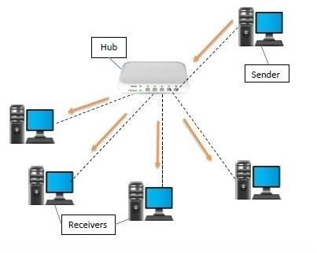

**SWITCH:**

A switch is a data link layer networking device which connects devices in a network and uses packet switching to send and receive data over the network.

Like a hub, a switch also has many ports, to which computers are plugged in. However, when a data frame arrives at any port of a network switch, it examines the destination address and sends the frame to the corresponding device(s). Thus, it supports both unicast and multicast communications. It is an intelligent network device that sends message to selected destination ports. It is supports unicast, multicast and broadcast. Transmission mode is full duplex. Collisions do not occur since the communication is full duplex. They are active devices, equipped with network software. The number of ports is higher – 24 to 48.

**BRIDGE:**

A bridge is a network device that connects multiple LANs (local area networks) together to form a larger LAN. The process of aggregating networks is called network bridging. A bridge connects the different components so that they appear as parts of a single network. Bridges operate at the data link layer of the OSI model and hence also referred as Layer 2 switches.

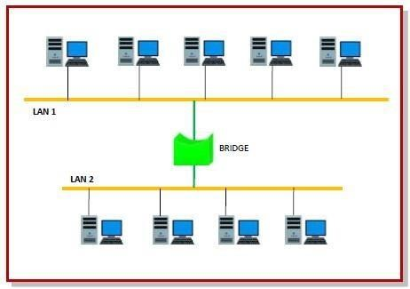

Uses of Bridge;

* Bridges connects two or more different LANs that has a similar protocol and provides communication between the devices (nodes) in them.
* By joining multiple LANs, bridges help in multiplying the network capacity of a single LAN.
* Since they operate at data link layer, they transmit data as data frames. On receiving a data frame, the bridge consults a database to decide whether to pass, transmit or discard the frame.

o If the frame has a destination MAC (media access control) address in the

same network, the bridge passes the frame to that node and then discards it. o If the frame has a destination MAC address in a connected network, it will forward the frame toward it.

* By deciding whether to forward or discard a frame, it prevents a single faulty node from bringing down the entire network.
* In cases where the destination MAC address is not available, bridges can broadcast data frames to each node. To discover new segments, they maintain the MAC address table. • In order to provide full functional support, bridges ideally need to be transparent. No major hardware, software or architectural changes should be required for their installation.
* Bridges can switch any kind of packets, be it IP packets or AppleTalk packets, from the network layer above. This is because bridges do not examine the payload field of the data frame that arrives, but simply looks at the MAC address for switching.
* Bridges also connect virtual LANs (VLANs) to make a larger VLAN.
* A wireless bridge is used to connect wireless networks or networks having a wireless segment.

**REPEATER:**

When an electrical signal is transmitted via a channel, it gets attenuated depending upon the nature of the channel or the technology. This poses a limitation upon the length of the LAN or coverage area of cellular networks. This problem is alleviated by installing repeaters at certain intervals.Repeaters amplifies the attenuated signal and then retransmits it. Digital repeaters can even reconstruct signals distorted by transmission loss.So, repeaters are popularly incorporated to connect between two LANs thus forming a large single

Repeaters are network devices operating at physical layer of the OSI model that amplify or regenerate an incoming signal before retransmitting it. They are incorporated in networks to expand its coverage area.

Repeaters are simple to install and can easily extend the length or the coverage area of networks. Repeaters don’t require any processing overhead. The only time they need to be investigated is in case of degradation of performance. They can connect signals using different types of cables. Repeaters cannot connect dissimilar networks.They cannot differentiate between actual signal and noise.They cannot reduce network traffic or congestion.Most networks have limitations upon the number of repeaters that can be deployed.

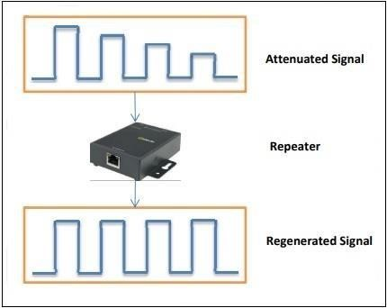

**ROUTER:**

Routers are networking devices operating at layer 3 or a network layer of the OSI model. They are responsible for receiving, analysing, and forwarding data packets among the connected computer networks. When a data packet arrives, the router inspects the destination address, consults its routing tables to decide the optimal route and then transfers the packet along this route.A router is a layer 3 or network layer device.It connects different networks together and sends data packets from one network to another.A router can be used both in LANs (Local Area Networks) and WANs (Wide Area Networks).It transfers data in the form of IP packets. In order to transmit data, it uses IP address mentioned in the destination field of the IP packet.

Routers have a routing table in it that is refreshed periodically according to the changes in the network. In order to transmit data packets, it consults the table and uses a routing protocol.

In order to prepare or refresh the routing table, routers share information among each other.

Routers provide protection against broadcast storms.Routers are more expensive than other networking devices like hubs,bridges and switches.

Cisco ,D-Link, HP,3Com ,Juniper ,Nortel are some popular router companies

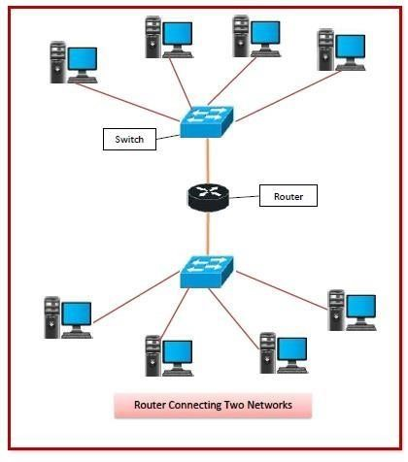

**PROCEDURE**:

**1.**Connect devices in Packet Tracer window:

2.Give IP address, gateway address to PCs.

3.Simulate and observe results.

**OUTPUT :**

1. **TOPOLOGY TO STUDY HUB OPERATION :**

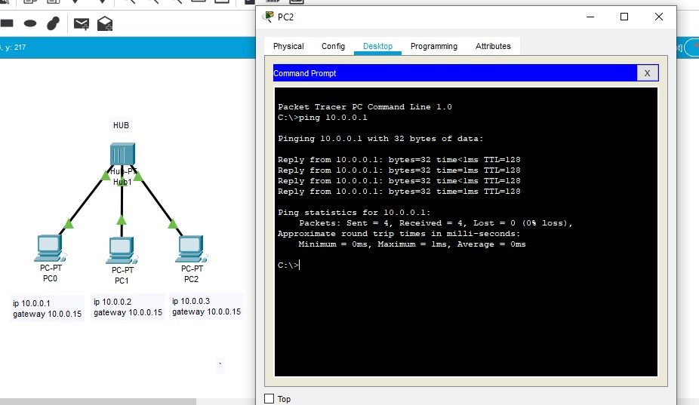

1. **TOPOLOGY TO STUDY SWITCH OPERATION :**

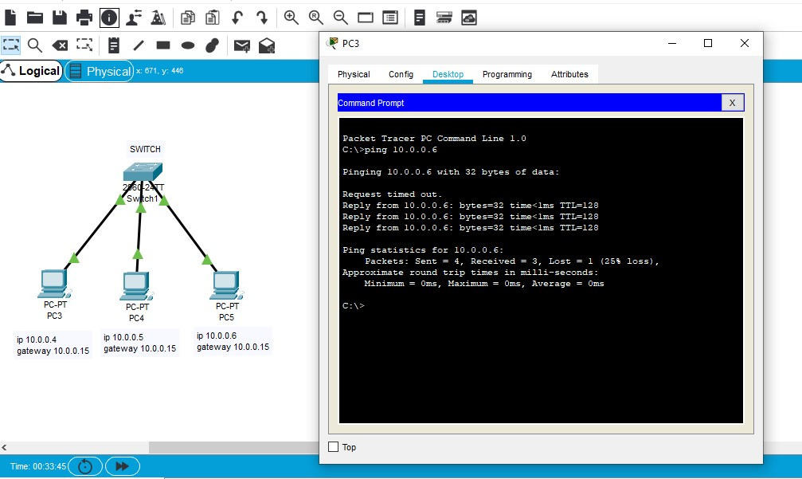

1. **TOPOLOGY TO STUDY BRIDGE OPERATION :**

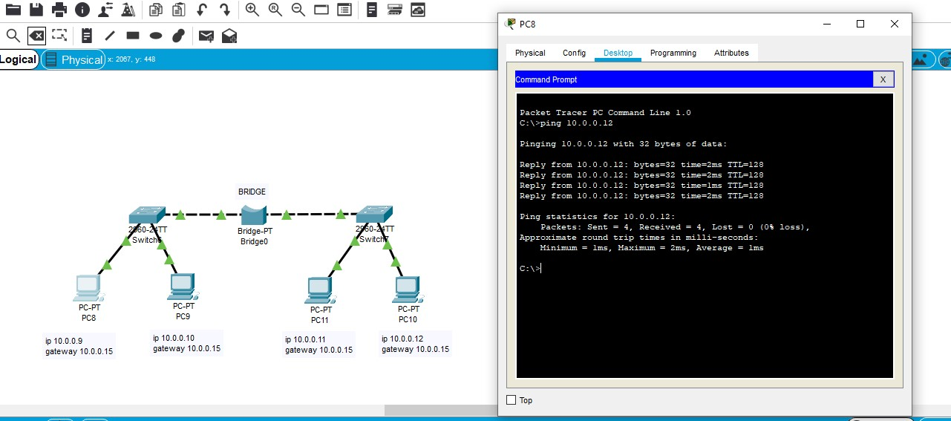

1. **TOPOLOGY TO STUDY REPEATER OPERATION :**

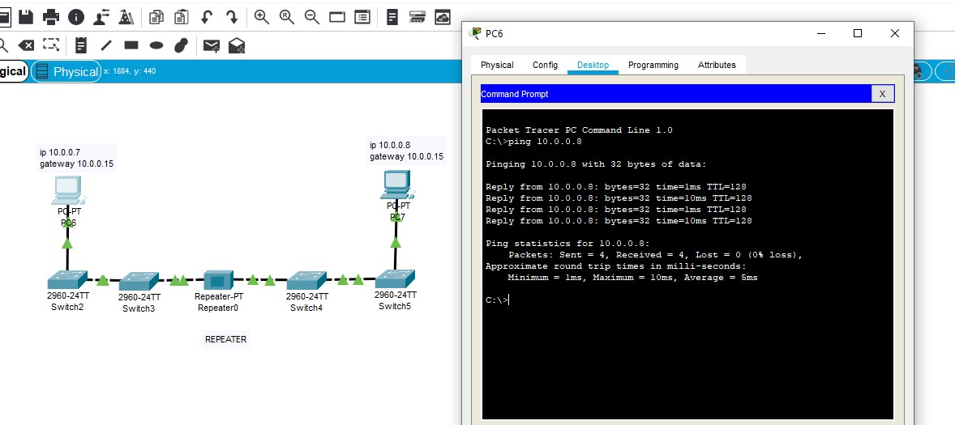

1. **TOPOLOGY TO STUDY ROUTER OPERATION :**

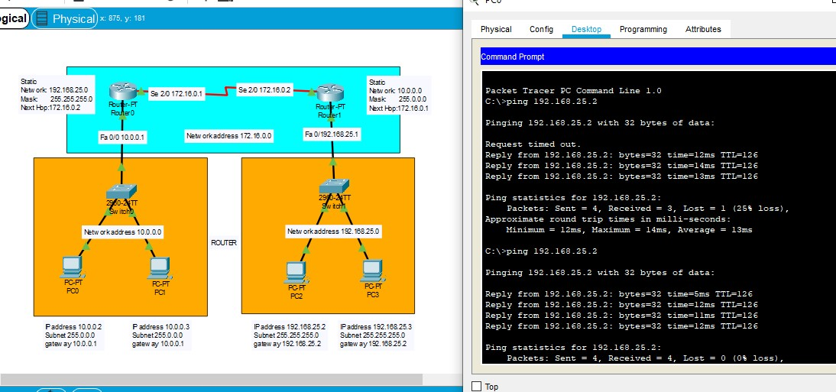

**CONCLUSION:**

Hence we successfully studied and simulated various networking devices using Cisco Packet Tracer by assigning IP, Gateway & Subnet Mask Address. We also studied and observed comparisons of different networking devices with respect to their parameters mentioned in the table in the questionnaire.

**Questions:**

1. **How does the HUB operate.**

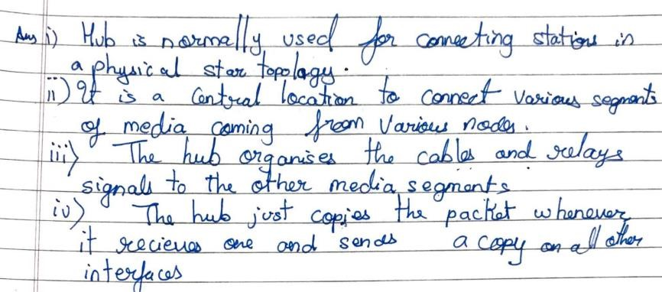

1. **Does the HUB understand any address?**

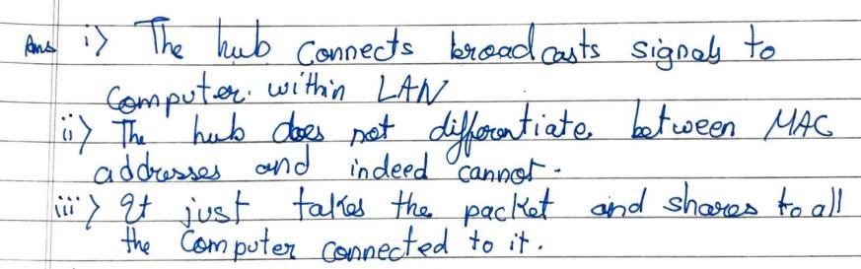

**3.**

**Write down the ARP table entries from a PC.**

**4.**

**what type of communication does a HUB always use ( broadcast or unicast)?**

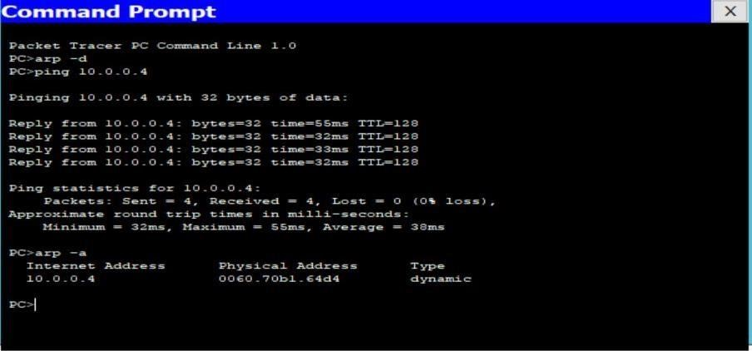

**5. At which layer of OSI model a HUB is used?**

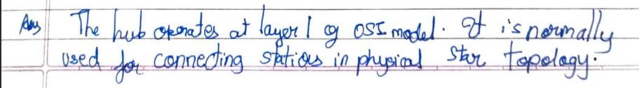

**6.**

**Note down the MAC/ARP table form the switch**

**7.**

**what type of communication does a switch use initially ( broadcast or unicast)?**

**8.**

**Which address does a switch understand?**

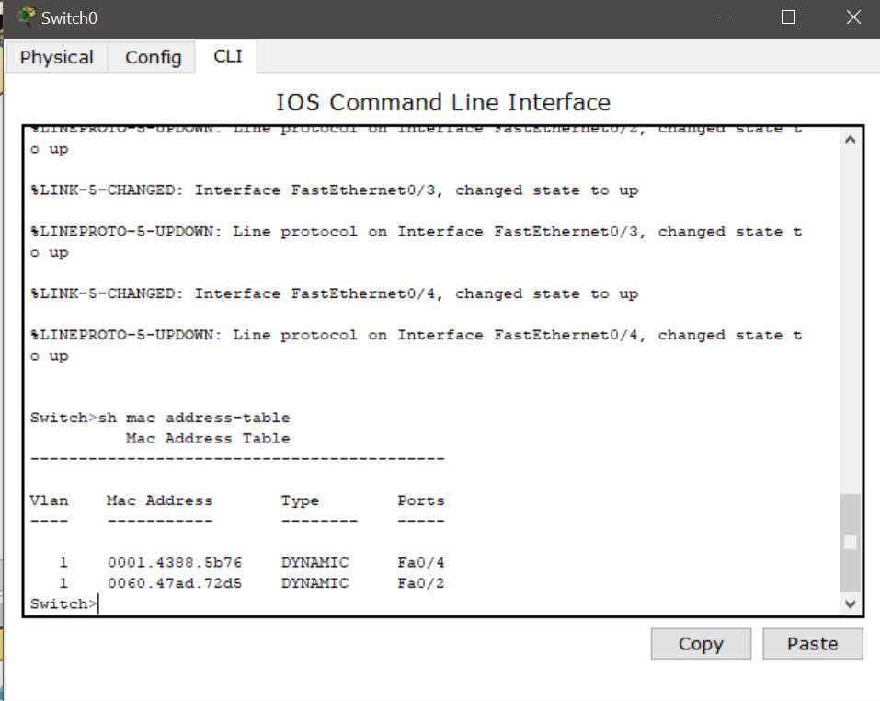



1. **At which layer of OSI model a switch is used?**



1. **List the protocols used by a switch?**

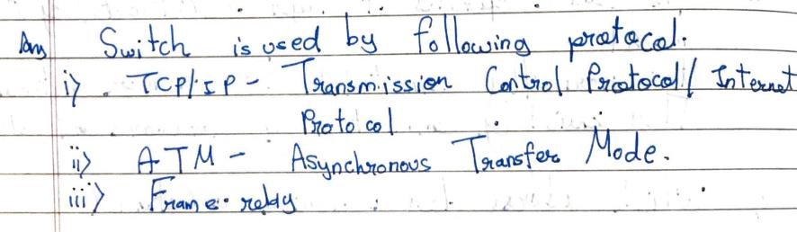

1. **Which table is maintained by a router?**

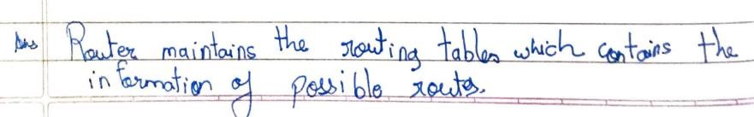

1. **Does a router connect two similar or dissimilar networks? Justify.**

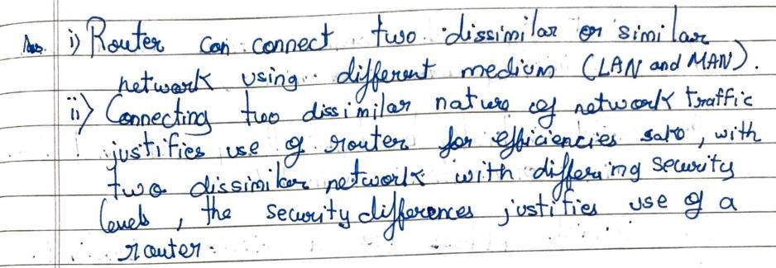

1. **Does the interfaces of a router belong to different or same networks? Justify.**

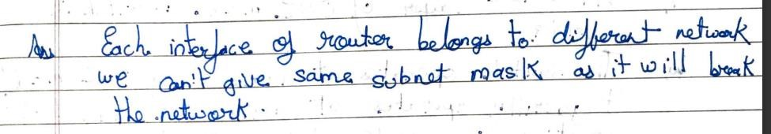

1. **At which layer of OSI model a router is used?**

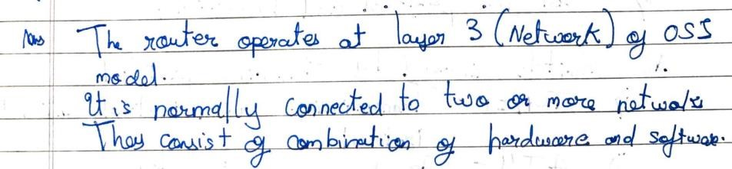

1. **Which address does a router understand?**

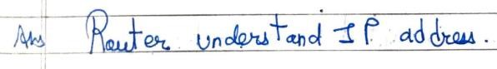

1. **Compare hub, switch and router.**

|  |  |  |  |
| --- | --- | --- | --- |
| **Parameter** | **HUB** | **SWITCH** | **ROUTER** |
| **Type of device** | **Broadcast** | **Point to Point** | **Point to Point** |
| **Layer of operation** | **Physical** | **Data Link** | **Network** |
| **Intelligence** | **Not Intelligent** | **Intelligent** | **Highly Intelligent** |
| **Used in** | **LAN** | **LAN** | **LAN, MAN, WAN** |
| **Address used** | **MAC** | **MAC** | **IP** |

1. **List all the networking devices**

